**Mr. Visca’s: Calculus (sec 6.2)**

**Chpt 6 – Day 2: AntiDifferentiation by Substitution**

The chain rule allows us to differentiate a wide variety of functions, but we are able to find antiderivatives for only a limited range of functions. We can sometimes use substitution to rewrite functions in a form that we can integrate.

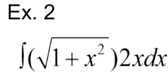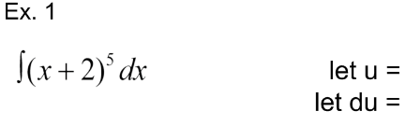

One of the clues that we look for

is if we can find a ______________ and its __________________in the integrand.

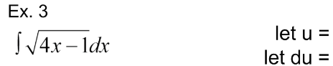

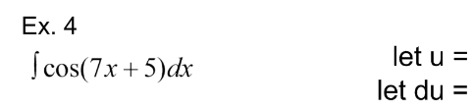

We solve for _________ because it is in the integrand.

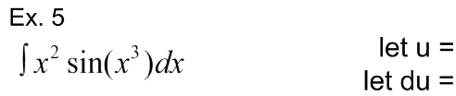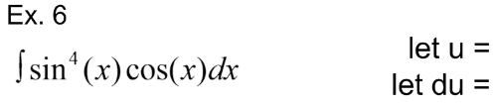

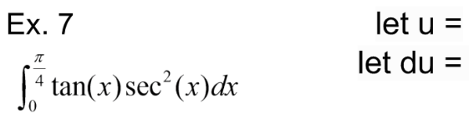***Definite Integrals***

**2 Methods:**

**U-Sub Bounds Original Bounds**

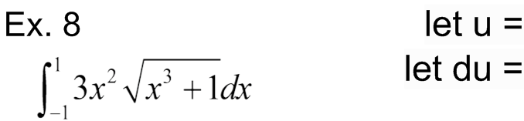

**Separable Differentiable Equations**

A separable differential equation can be expressed as the _______________ of a function of *x* and a function of *y*

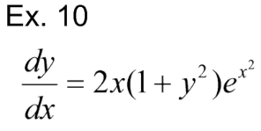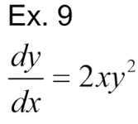

1. Get ____________ alone on one side

2. _________________ both sides

3. Solve for ______

HW: section 6.2

#s:1 - 6, 18,20,22, and 53-65 odd